**Short Term Top Down Analysis - Daily To 4 Hour**

This is ICTs full trading plan, he uses the same setup everytime, this is how he is so accurate, there is no secret sauce he says.

If ICT forces himself behind the charts every day then he is not accurate, wait for specific conditions

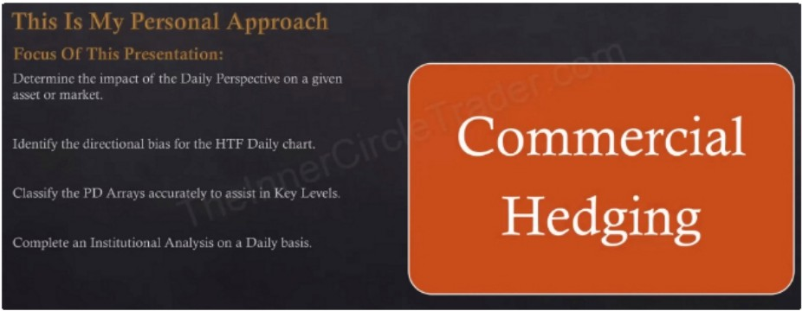\II \I,, 1 ',: ', \\ , \I I l 11 I I ,

### Com.m.ercial Hedging

First thing on the daily timeframe is COT

We create our own O line, highest high and lowest low of the 12 month range, divide that and we have our new O line, above the O is bullish and below is bearish

Everything from the monthly and weekly carries over, preferably the daily should confirm the bias of the monthly and weekly

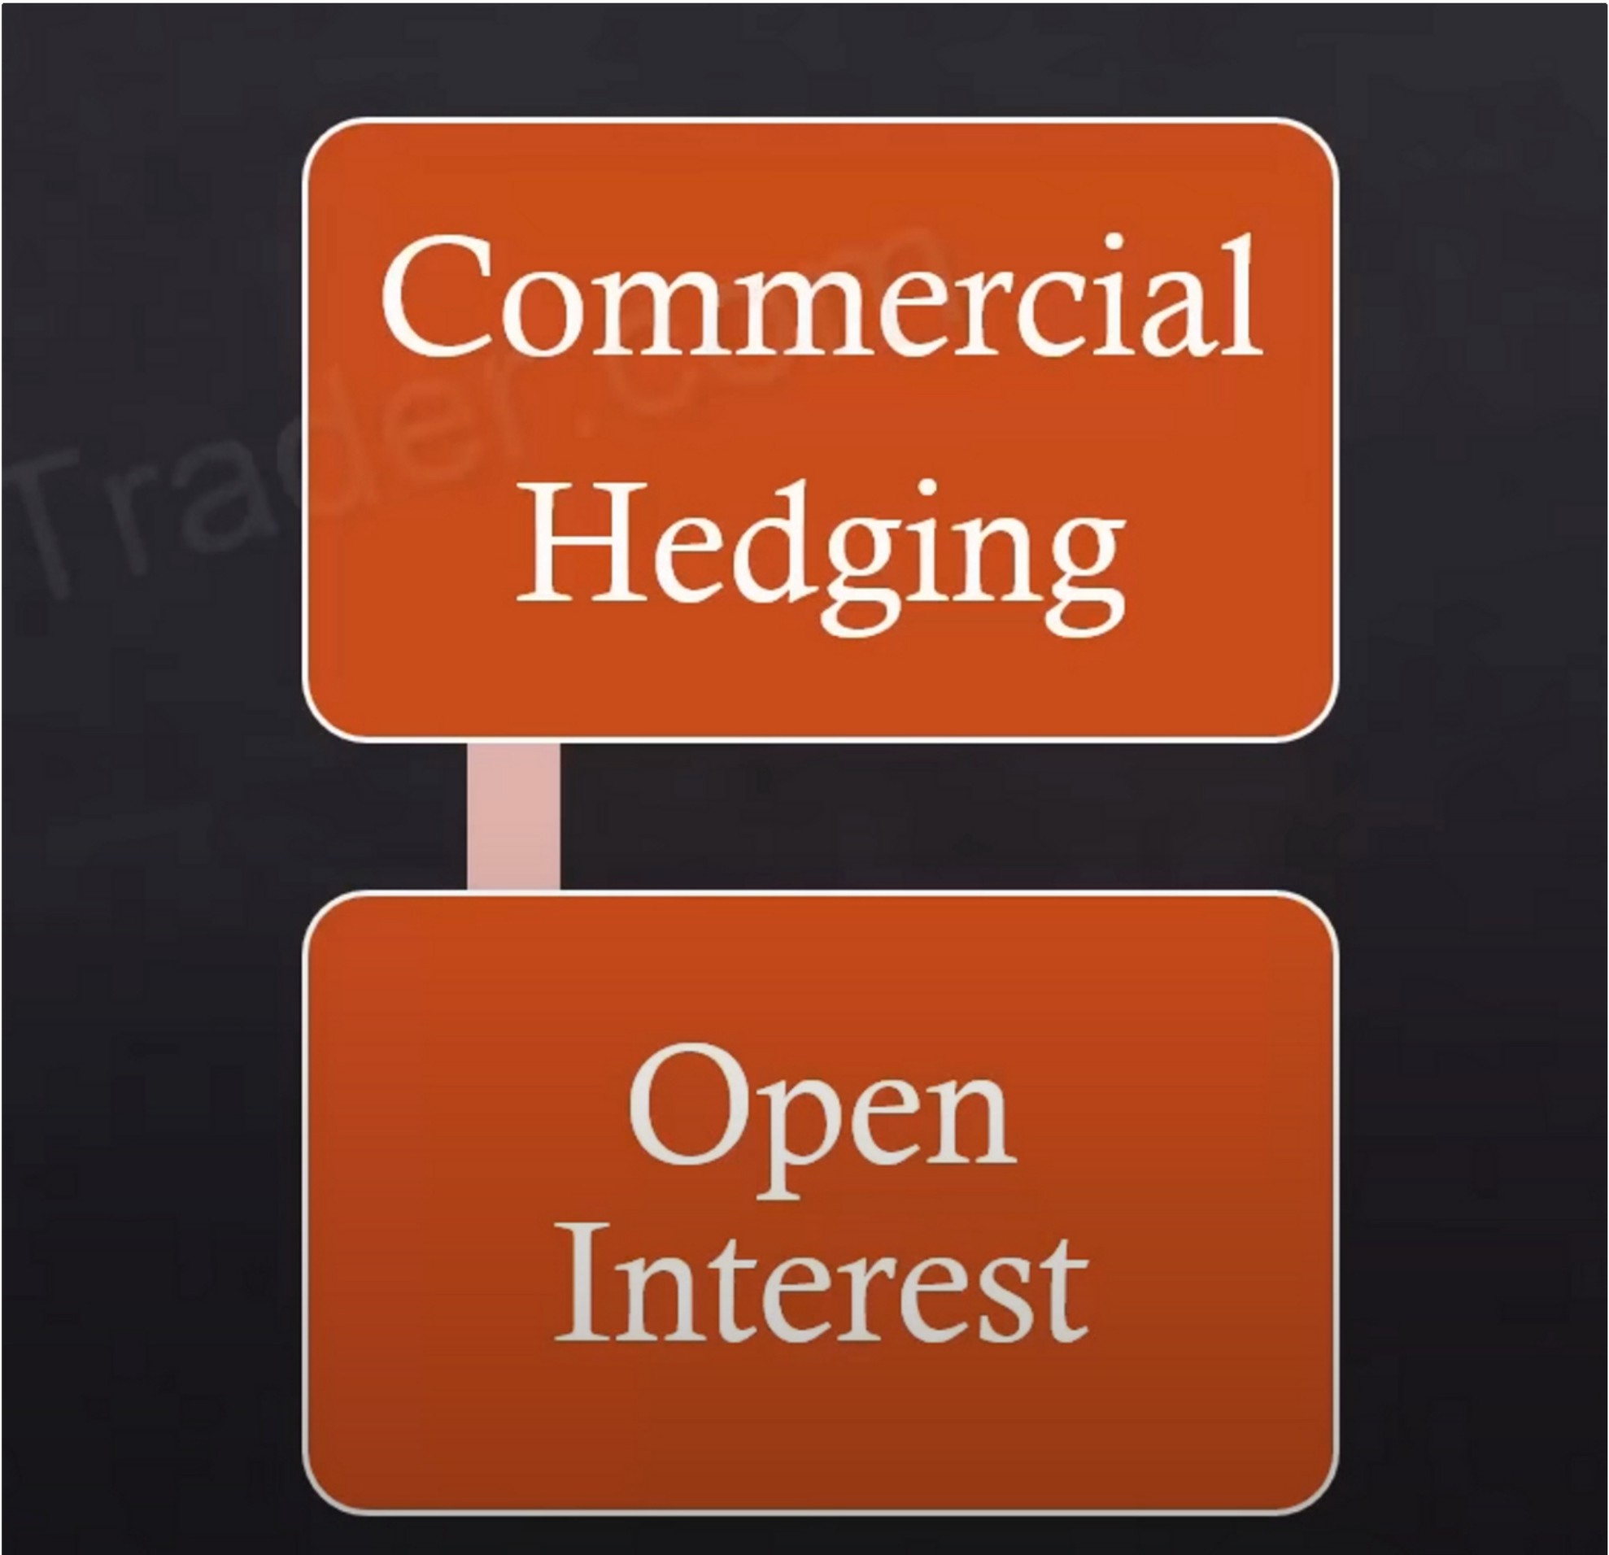

For currencies we refer to the futures contract for the open interest

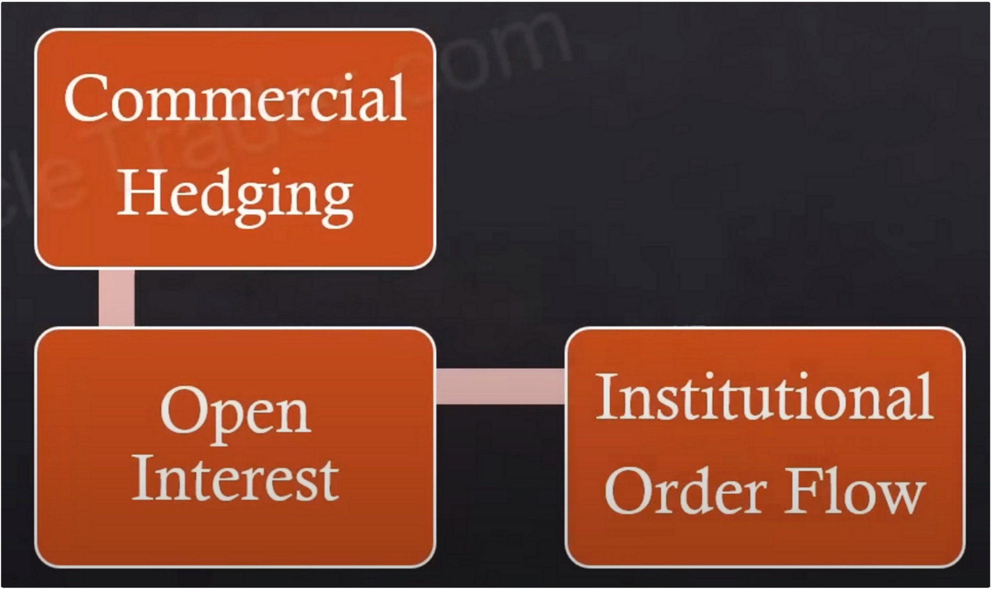

Institutional orderflow on the daily timeframe Are we seeing sponsorship?

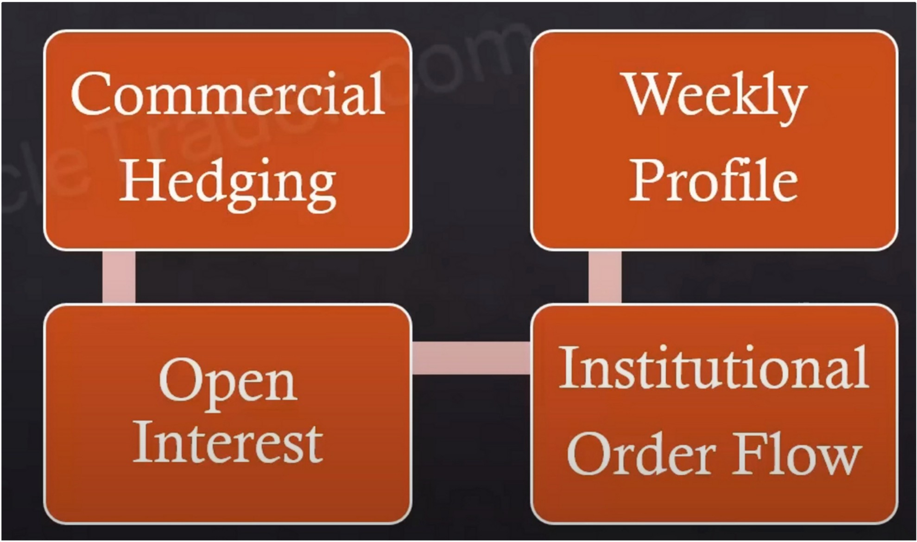

What weekly profile is most likely going to unfold?

Use the economic calendar to start framing this and if i cant arrive at that, we go with our best assumptions and if were wrong we refer to the economic calendar later in the week to correct our assumptions and there may be a weekly profile that works the later half of the week

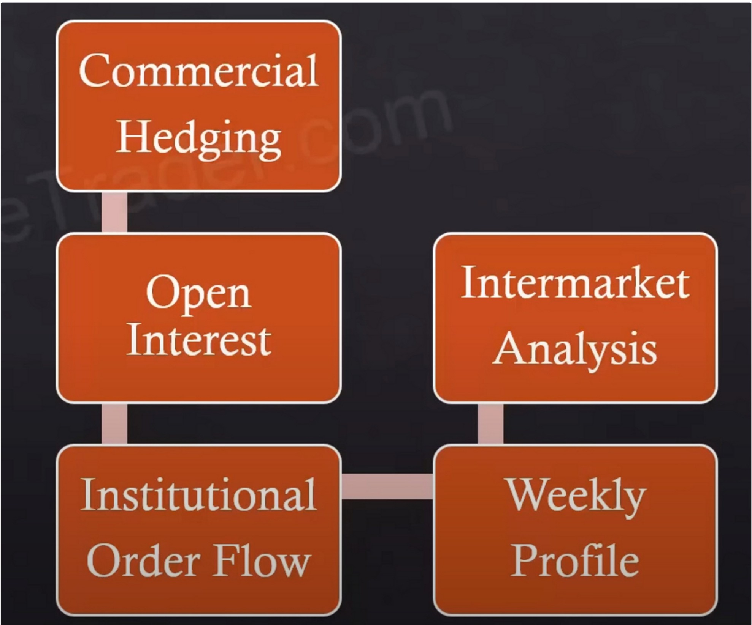

Correlated assets/pair SMT divergences etc

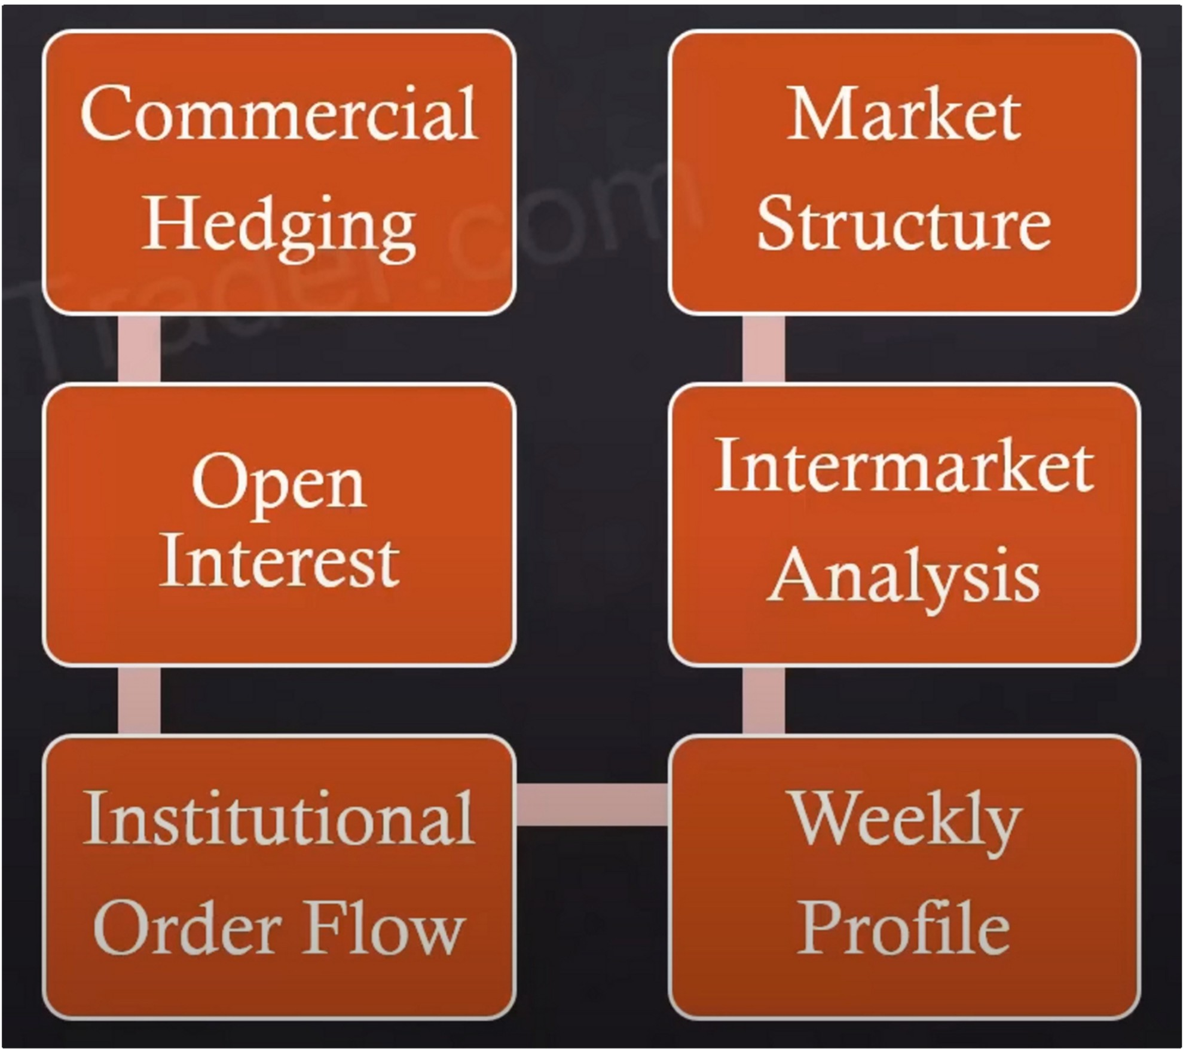

Start to incoorporate heavier use of breakers and mitigation blocks

And we want to look at overall bullish market structures and bearish market structures and maintaining that overall institutional orderflow while were creating a larger degree of market structure swings

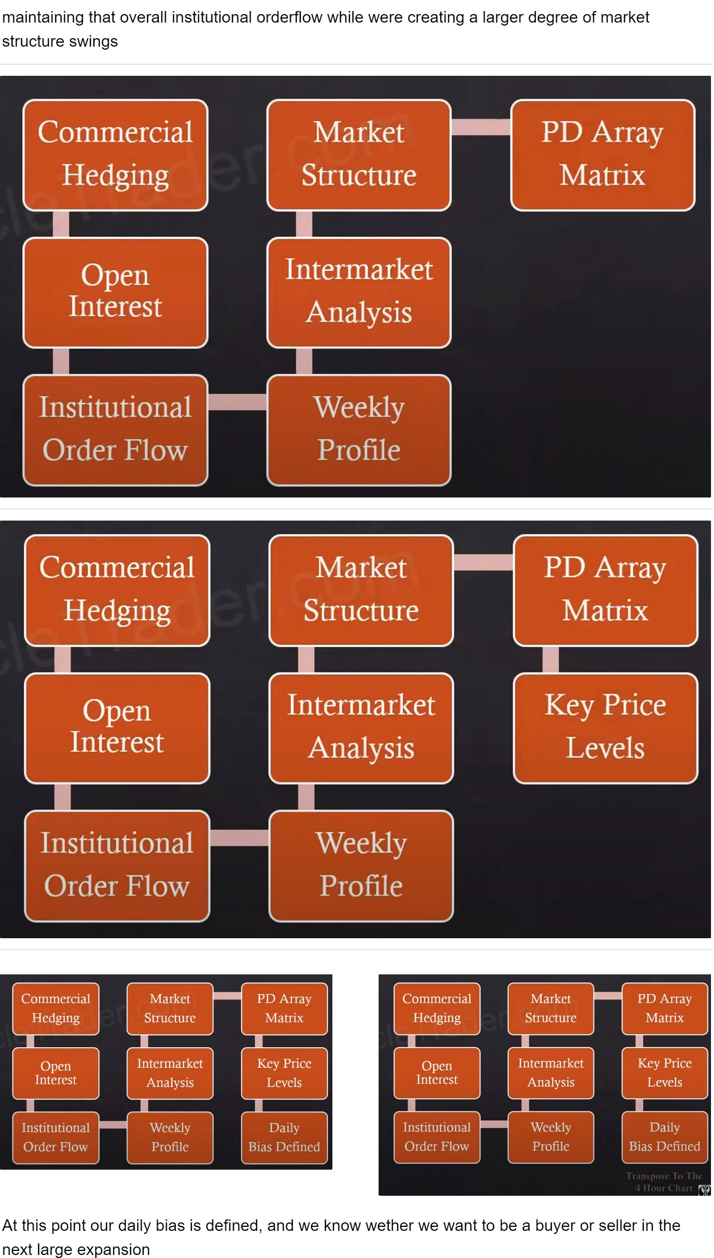

Commercial Hedging

Market Structure

PD Array Matrix

Commercial Hedging

Market Structure

PD Array Matrix

Open Interest

Intcrmarket Analysis

Key Price Levels

Open Interest

lntermarket Analysis

Key Price Levels

Institutional Order Flow

Weekly Profile

Daily Bias Defined

Institutional Order Flow

Weekly Profile

Daily Bias Defined

**,..n**

At this point our daily bias is defined, and we know wether we want to be a buyer or seller in the next large expansion

Remember, the banks use mostly the daily chart, very important timeframe Transpose everything to the 4h chart

l (II] 11h I I 11 ,I Ill

In the proc·ess of devdoping an opinion of Smalt l'vlonev and their respective actions in the market I refer to the last I 2 months of the Cnmmercial Hedgers Commitment Of Traders Net Holdings. [6 months if narrow range.[

I determine the 11,ghest and Lowest readings in the COT l.111e Ch.tr! .ind then ,·isu.tlh· di11dc· 1h,11 r.tngc in h.tlf

I c1JJhlcic·1 1h,·11 ,·1 l'll'1illlJl llu111'h 11 ,1b111,· the· Ii.ill 11,11 rn,irk (ll 1171: 1 lll1J11th 1.1!1_'..!1.' ,111-l Hl,!11,h i1 h·lti\\ th1.' 11.tl!

\\,!\ lll,ltk 1)1 till' I.' :lltllllh :,lll_ '.l

# Commercial Hedging

Commitment of traders

Usually and mostly we use the 12 month range, so whatever today is go back 12 months

ICT said: "if were below half way then ill be focusing on discount arrays and looking for scenarios where the market should expand to the upside reaching for some measure of a premium"

Kinda confused, because thats not how he explained it, maybe he just said it wrong?

I get it now, because when were below it it means theyre selling and price will likely come back down to a discount and then they start buying again, like on the previous lesson

t )i, II I I I(

Once mv .tn.llvsis t,1kcs me into the Dailv timeframe consider I he use or Open I ntcrest.

I 11·,1111 to see Open lntnest Decline about l:i"o or more when Price is trading at a HTf Discount Arra,· - Bullish.

I011 urmore

I w.mt to '.'il'l' ()pl'tl lntt'fT:-;t lnLTl'<lSl' .tbnut

11h,·11 l'n,·,· is 1r.id111g .11 .i I !Tl l'r,·1111u111 ,-\n,11 llc,1rish.

In l11.:t,,1.·1.·11 ,:i1h1.:1· tit th1: ,1\in\1.' 1.·1nhliti1111" *(* )111.·11 l11h.:11.'"l

i, tlrll l11:1,1lkt1.·l! 111 1'.l\ ,lrLil\-;j,

# Open

**Interest**

Open interest

Prior to the daily timeframe we dont look at open interest

It either has to meet 1 of these 2 criterias or we wont refer to open interest at all

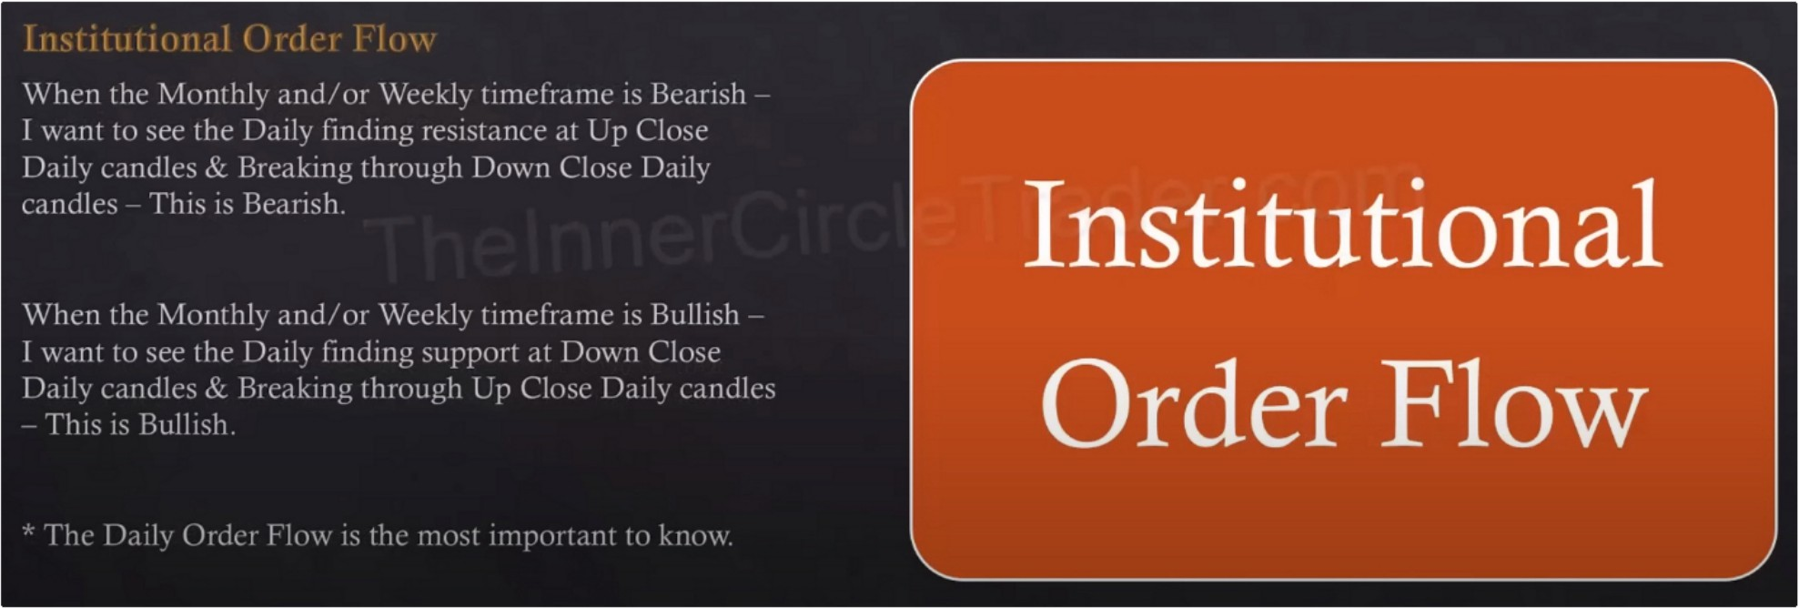

Institutional orderflow

If you dont want to look at the weekly and monthly and daily, which is absolutely not adived then at least stufy them from an institutional standpoint. If you dont know what the daily institutional orderflow is implying then you're playing russian roulette

\ \" I' I "I I,

\\'hl'n thl' \lonthh, \VL'cklv orjust thl' 0,1il\' 111nclra111c

lk,1rish

suggests the m.11kct is - I st,nt looking for Si..'l'n,nios

th,ll might prnducc spcc1liL' Hc,uish \Vcckl - Protilcs.

\\'hl'n th,· \lonthh,

Bullish

\Vcl'kl\'

:--uggcsts thl' m,nk ·t is

m1us1 thl' IJ.,il\' ttml'lr,1111,·

I slart llloki;1g for SLTll,nios

## Weekly

th,11 might pl<lducc' SJ'L'c'tlic llullish \\'L'ckh l'rntiks

l'L'!1 inmirhl 1hc \\'l'l'l-h l\.1nge I\ pil·,ilh tnrm-.; l1L'l\\l'l'll

Tul·-.;,L1\ ,\: Thu1...;d,1\ l·:-.111 1\w 1.·.1k11d,11 l1H d11\l'I' \\ill ,1-.;-.;1-.;1

l1u1 !lll'tt' 1-- lltl 1.·11t1l-1L'-L utlt't tl!h' ,,,1, llt, .ill lll'IL' L'L' \l.111. li

,-()J11l·11t !tlt 1.ku:I" I ,!1,1l II1 li:1 tht· \\1.·t·kh < )11t·n 1;1: l\i,,1.·1 < )I

111!:1,T.ll0'- 11:1 tllt' \\l·1:l.h l .11: :1

## Profile

Weekly profile

Tuesday trough thursday is the bulk of the week, when bullish we expect mostly for tuesday to be the low of the week and thursday to be the high of the week and monday and friday just consolidations vice versa for bearish week, it isnt always the case but thats how we adopt all of our bullish and bearish scenarios, we start there

Thats why ICT usually sits on his hands on monday, he wants that tuesday trough thursday portion

Youre never going to get it every single week, but if we can get very close to what may unfold and focus around the economic drivers for liquidity runs and manipulation and get in sync with that we can anticipate a specific type to occur, as long as its in sync with our HTF bias and at least the daily if the monthly and weekly are weird or theyre contradicting each other

Start in the weekend with looking at the economic calendar and what session and what type of profile might occur based on the PD arrays and economic calendar

Sunday open and also look at the monday MNO and drag it across the weekly and every day we look where were at in relation to mondays new york midnight open

So we have 2 opening prices for the weekly range

When bullish preferably we want to see price below the opening prices into a discount array

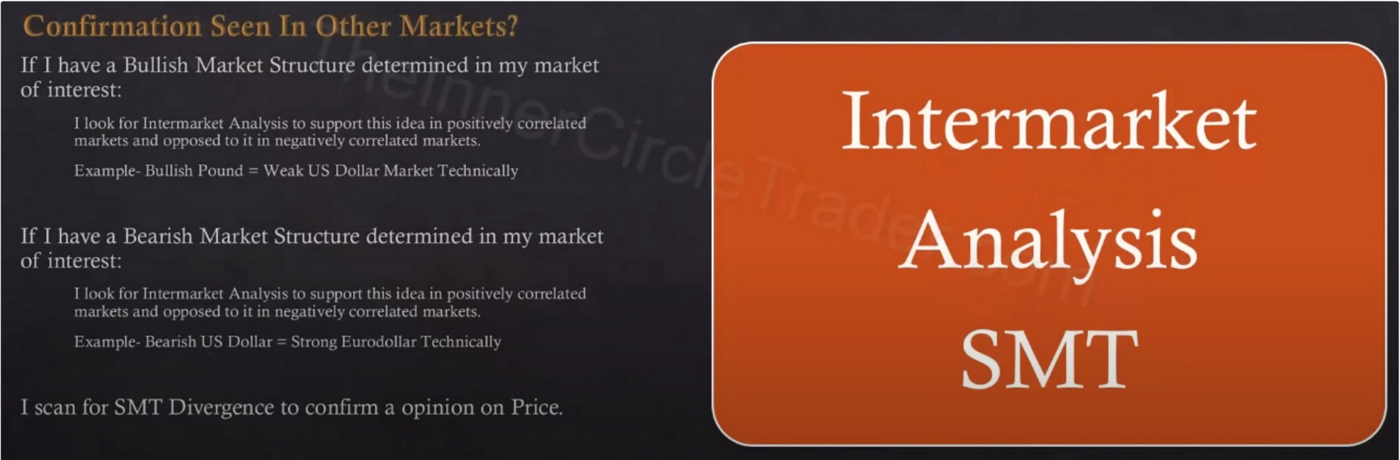

SMT divergence from daily going to 4h because thats where its most effective

I I ) l I 1111 I I 1 \ { 111 I\ 11 i \ I .1 i I I \ I I: I

<.·urrcnt -Lirkct Structun..• I dassitV recent I lighs ;rnd I ,ows.

I sL·.111 fur I IIT I )iscount :\n.1ys th.tt might the

**Marl(et**

present

lm111,lllllll ol !\l.nkct :\l,tkcr Buv I\IDLkis This \\ill st,tgc

multiple cnnic:-. fnr Longs on the lnwc1 timcf1.1mcs.

I sc,111 l<ll HTf Prc111iu111 i\rr.rvs th,ll might pr,·smt the·

TlllS

lonn,1tHm ol :\L11 kc·t :\L1k,·1 Sdl !\!odds. 11111 st,1g,·

multi pk L'IltliL'S ru1 Shurts 011 thL' hl\\'L'J til11L'fr,ltnl'S

! ltl\lk !ti! l'o!l',lh.l'l's 111 !l1l' l),11h llllll'l!.ltlll' lll1Yl' 1:1.111 ,!11\

t i1h1.·1 I( lll l\\ \\ hl'lt' lht''-.t' ,!!\.', ,!17 ,ill'! 1 \ t l\l '.l l '.Ill· Ill'\!

lllll'l'l)l'l!:.tll' l,-1'1'. 111:,t·'.'-o\\

### Structure

Looking for breakers and mitigation blocks on the daily timeframe more then any other timeframe, because knowing this and where they exist they can alert you as to where the next intermediate price swing will unfold

If you go trough old PA you can see it goes from bullish breaker to bearish breaker and its the meat in the middle that we want to be apart of

Its easy when you know where these breakers are

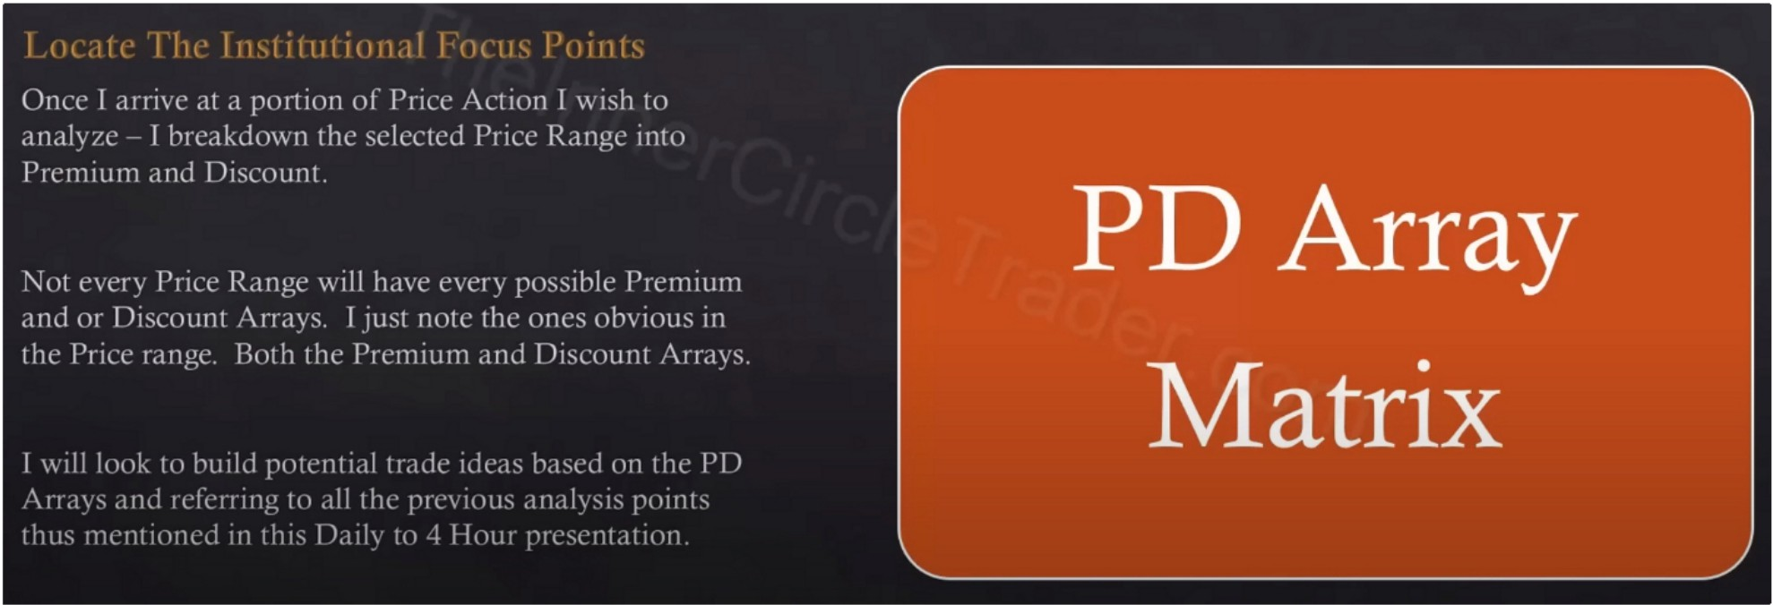

We have to know our PD arrays to know where price will trade from and where it will reach

If were bullish on a market doesnt mean were buying every single day, it has to come to some measure of discount array at a specific time of day. And preferably with a manipulation driver on the economic calendar

You have to go trough all the content otherwise this wont make sense, you have to study it for yourself thats when it will make sense, no hand holding.